GENERATIVE MODELS VS TRADITIONAL AI-DRIVEN ANOMALY DETECTION IN LARGE-SCALE SYSTEM LOGS – A COMPARATIVE STUDY


by

Muhammad Asad Mahmood Khan
M.S., Artificial Intelligence, Air University, 2026

A thesis submitted in partial fulfillment of the requirements for the degree of
Master of Science in Artificial Intelligence

AIR UNIVERSITY
2026

GENERATIVE MODELS VS TRADITIONAL AI-DRIVEN ANOMALY DETECTION IN LARGE-SCALE SYSTEM LOGS – A COMPARATIVE STUDY


by

Muhammad Asad Mahmood Khan
A thesis submitted in partial fulfillment of the requirements for the degree of
Master of Science in Artificial Intelligence
SUPERVISOR
Prof. Dr. Imran Ihsan

AIR UNIVERSITY
ISLAMABAD
© [Muhammad Asad Mahmood Khan] [2026]. All rights reserved.

CERTIFICATE

Department of Creative Technologies

It is hereby certified that Muhammad Asad Mahmood Khan (243260) has successfully completed his thesis.

Dr. Imran Ihsan
Professor
Air University
Supervisor

Dr. Tahir Akram  Associate Professor  Air University  Internal Examiner  Guidance and Evaluation Committee | Dr. Junaid Ali khan  Associate Professor  HITEC University  External Examiner  Guidance and Evaluation Committee

Dr. Imran Ihsan  Associate Professor  Air University  Chair Department of Creative Technology | Dr. Mehdi Hassan  Professor  Air University  Dean Faculty of Creative Technology

________________________________
Dr. Mehdi Hassan
Air University
Dean Faculty of Graduate Studies

DECLARATION
I declare that all material in this thesis is my work, and that which is not my own work has been mentioned as such, and that no material from this work has previously been submitted or approved for the award of a degree by this or any other university.

Signature:
Author’s Name: Muhammad Asad Mahmood Khan
Dated: ___________

It is certified that the work presented in this thesis is carried out and completed under my supervision.

Signature:
Supervisor’s Name: Dr. Imran Ihsan
Professor
Department of Creative Technology
Air University, Islamabad
Dated: ___________

Acknowledgments

Firstly, I am thankful to Allah Almighty for giving me the courage and strength to complete my Masters. Also, I would like to thank my supervisor Dr. Imran Ihsan for their essential advice and assistance throughout my master's programme. They gave me guidance and encouragement as I completed this research and prepared this thesis.
I also want to express my gratitude to my extended family and friends for their love and support throughout this process.
I would give my parents credit for this and all of my accomplishments. They gave me every chance to develop and did everything to support my development into a confident, intelligent man.

Generative Models Vs Traditional Ai-Driven Anomaly Detection In Large-Scale System Logs – A Comparative Study
by
Muhammad Asad Mahmood Khan
M.S., Artificial Intelligence, Air University, 2026
Submitted in partial fulfillment of the requirements for the degree of
Master of Science in Artificial Intelligence, Air University

Abstract
The escalating scale and complexity of distributed computing architectures, specifically Hadoop (HDFS), Apache Spark, and OpenStack, have rendered manual and rule-based log monitoring fundamentally intractable. This research presents a comprehensive comparative study evaluating Traditional Machine Learning (ML), sequence-based Deep Learning (DL), and Generative AI models for automated anomaly detection within massive, unstructured log collections.
Initial benchmarking demonstrates a critical functional dichotomy in current industry standards. Traditional supervised algorithms achieve high precision on structured data but remain brittle, relying heavily on labor-intensive manual feature engineering and labeled datasets. Furthermore, traditional unsupervised baselines, like Isolation Forest, exhibit significantly lower efficacy when processing high-dimensional sequences, exposing a severe gap in identifying unknown, zero-day errors.
To transcend these limitations, this thesis rigorously evaluates deep sequence and Generative AI architectures (including LSTMs, VAEs, and GANs). To ensure accurate assessment across heterogeneous environments, models are independently trained and tested within the same respective dataset boundaries for HDFS, Spark, and Hadoop, establishing true baselines without cross-system contamination.
This study delineates the operational boundaries of these paradigms. Findings reveal that while supervised Deep Learning eliminates manual feature extraction, Generative AI provides superior automation via a normal-only training paradigm. Ultimately, this research validates Generative models' capacity to discover unknown anomalies while detailing precision trade-offs in concurrent environments like Spark.
Thesis Supervisor: Prof. Dr. Imran Ihsan
Table of Contents
Chapter 1: Introduction 10
1.1 Problem Statement 10
1.2 Motivation 12
1.3 Objectives 12
1.4 Scope of the thesis 13
1.5 Thesis Layout 14
Chapter 2: Literature Survey 15
2.1 Foundations 17
2.1.1 Books 18
2.1.2 Papers 18
2.1.3 Experiments 19
2.2 Prior Work 19
Chapter 3: Mathematical Formulation 21
3.1 Log Sequence Representation 21
3.2 Sequence-Based Deep Learning (LSTM) 21
3.3 Generative AI (Variational Autoencoder) 21
3.4 Generative Anomaly Scoring 22
Chapter 4: Methods Developed 23
4.1 Mathematical Formulation of the Detection Problem 23
4.2 Phase 1: Multi-Source Dataset Collection 24
4.3 Phase 2: Log Preprocessing & Parsing (Enhanced) 24
4.4 Phase 3: Comparative Model Architectures (Enhanced) 24
4.4.1 Traditional Machine Learning (Manual Feature Engineering) 24
These models depend heavily on the aggregation of Event Count Matrices. 24
4.4.2 Deep Learning (Sequence Embedding) 25
4.4.3 Generative AI (Raw Log Embeddings) 25
Chapter 5: Results and Discussion 26
5.1 Baseline Performance (HDFS v1) 26
1)Traditional Machine Learning Results: 26
5.2 Spark Logs Analysis 32
5.3 Spark Comparative Analysis Synthesis: 37
Chapter 6: Conclusions and Recommendations 45
6.1 Conclusions 45
6.2 Recommendations for Further Work 45

List of Figures
Figure 1 Methodology 23
Figure 2 HDFS ML XGBoost Confusion Matrix 28
Figure 3 Shuffling Test Performance 28
Figure 4 F1 Score 28
Figure 5 SVM results 29
Figure 6 SVM Confusion Matrix 29
Figure 7 SVM Results after Shuffing 30
Figure 8 DL LSTM Confusion Matrix and ROC-AUC results 31
Figure 9 GRU Confusion Matrix and ROC-AUC results 31
Figure 10 GEN AI LSTM Autoencoder Confusion Matrix and ROC-AUC results 32
Figure 11 GEN AI LSTM VAE Confusion Matrix and ROC-AUC results 33
Figure 12 HDFS Comparison Matrix 34
Figure 13 Spark ML Train and Test Results 35
Figure 14 Isolation Forest and Random Forest Results 35
Figure 15 DL Train and Test Results 36
Figure 16 LSTM Results 36
Figure 17 CNN Results 37
Figure 18 DL vs ML Comparison Results 37
Figure 19 Gen AI Train and Test Results 38
Figure 20 VAE Results 38
Figure 21 GAN Results 39
Figure 22 Spark logs Model Comparison 40
Figure 23 Spark logs Confusion Matrix 40
Figure 25 Hadoop ML Label Logs distribution 41
Figure 26 ML Isolation Forest and Random Forest Results 42
Figure 27 DL train test results 43
Figure 28 LSTM Autoencoder Results 43
Figure 29 CNN and LSTM comparison 44
Figure 30 Gen AI train test results 44
Figure 31 VAE and GAN results 44
Figure 32 Hadoop All Model Results Summary 45
Figure 33 Hadoop All Model Confusion Matrix 45
Figure 34 Performance Matrix Spark vs Hadoop 47

List of Tables
Table 1 HDFS All Models Comparison 33
Table 2 Spark Logs All Model Results Summary 41
Table 3 Spark vs Hadoop All Models Results 46

Symbols and Abbreviations
Abbreviation | Definition
AI | Artificial Intelligence
ANN | Artificial Neural Network
AUC | Area Under the Curve
DL | Deep Learning
ELBO | Evidence Lower Bound
FN | False Negative
FP | False Positive
GAN | Generative Adversarial Network
GRU | Gated Recurrent Unit
HDFS | Hadoop Distributed File System
KL | Kullback-Leibler
LSTM | Long Short-Term Memory
ML | Machine Learning
NDM | Next Day Monitoring
NLP | Natural Language Processing
OOD | Out-of-Distribution
PCA | Principal Component Analysis
RNN | Recurrent Neural Network
ROC | Receiver Operating Characteristic
TN | True Negative
TP | True Positive
VAE | Variational Autoencoder
YARN | Yet Another Resource Negotiator

Symbol | Description
E | Parsed log sequence
et​ | Feature embedding of a log event at time step t
ht​ | Hidden state of the recurrent network at time step t
T | Total length of the temporal log sequence
V | Vocabulary size of possible unique log events
W,b | Weight matrix and bias vector of a neural network layer
z | Latent space vector representation
x | Input data (e.g., original log sequence)
y | True label (used in supervised benchmarking)
y^​ | Predicted output or reconstructed sequence
Rd | d-dimensional real coordinate space (used for embeddings)
E | Expected value / Expectation
pθ​(x∣z) | Probabilistic decoder parameterized by neural network weights θ
qϕ​(z∣x) | Probabilistic encoder parameterized by neural network weights ϕ
μ | Mean vector of the learned latent distribution
Σ | Covariance matrix of the learned latent distribution
N(μ,Σ) | Multivariate Normal (Gaussian) distribution
LVAE​ | Evidence Lower Bound (ELBO) loss function for VAE
DKL​ | Kullback-Leibler divergence
A(x) | Anomaly score based on reconstruction loss
τ | Dynamic anomaly detection threshold
∥⋅∥2 | Squared L2​ norm (Euclidean distance, used in reconstruction error)
∇ | Gradient operator (used in optimization and backpropagation)
α | Learning rate during model training

Introduction
System logs serve as the definitive operational artifacts and the primary source of truth for diagnosing failures, tracking execution flows, and ensuring security within modern cloud infrastructures. In contemporary distributed computing paradigms—such as the Hadoop Distributed File System (HDFS) and Apache Spark frameworks—a single user transaction routinely cascades into complex execution traces spanning thousands of interconnected and concurrent nodes. This immense concurrency generates terabytes of heterogeneous, unstructured, and semi-structured log data at unprecedented velocities.
Historically, system administrators relied on manual inspection, simple keyword matching (e.g., flagging "FATAL" or "ERROR" strings), and static, rule-based heuristics to identify performance bottlenecks or impending system crashes. However, as infrastructural scale and software complexity continue to grow exponentially, these traditional paradigms have become fundamentally obsolete. The sheer volume, high dimensionality, and continuous semantic evolution of these log formats make it practically impossible for human operators or rigid diagnostic scripts to capture the nuanced, temporal deviations that often precede catastrophic system failures.
Consequently, the industry has necessitated a critical paradigm shift toward Artificial Intelligence and automated telemetry. The application of sophisticated Artificial Intelligence—spanning Traditional Machine Learning (ML), Deep Learning (DL), and Generative AI architectures—to parse, embed, and analyze these massive log collections has emerged as a pivotal research frontier. Developing robust, automated anomaly detection systems is no longer just an optimization strategy, but an operational necessity for maintaining system reliability, ensuring high availability, and mitigating the immense costs associated with infrastructure downtime.

Problem Statement
As distributed computing environments, such as Hadoop and Apache Spark, continue to scale in complexity, system logs remain the primary diagnostic artifact for troubleshooting and performance monitoring. However, the sheer volume, velocity, and unstructured nature of these logs have rendered manual, rule-based inspection obsolete. Consequently, current industry standards for automated log anomaly detection are paralyzed by a critical functional dichotomy between accuracy and adaptability.

- Brittleness of Supervised ML:
Traditional discriminative models, including Support Vector Machines (SVM) and extreme gradient boosting (XGBoost), can achieve exceptionally high detection accuracy in closed-world scenarios. However, they are fundamentally brittle. These architectures are entirely dependent on rigid, manual feature engineering (e.g., Event Count Matrices) and extensive, pre-labeled anomaly datasets. This reliance causes them to fail catastrophically in the face of concept drift—such as when log syntax naturally evolves during software updates, or when models are ported across heterogeneous system architectures.
- Inefficacy of Unsupervised Baselines:
Conversely, traditional unsupervised techniques (e.g., Isolation Forest, One-Class SVM) attempt to bypass the need for labeled data by isolating statistical outliers. Yet, they consistently struggle to map the complex, temporal, and sequential dependencies inherent in distributed execution traces. This structural blindness results in unacceptably high false-positive rates and poor detection efficacy when encountering novel, unknown error patterns (zero-day anomalies) within noisy, highly concurrent environments. There is a critical lack of a unified framework that combines the high accuracy of supervised learning with the flexibility of unsupervised discovery.
Ultimately, there remains a critical lack of a robust, unified framework capable of bridging this operational gap. Existing paradigms force a compromise: engineering teams must choose between the high precision of supervised learning—which demands unsustainable manual labeling and feature extraction—and the flexibility of unsupervised discovery, which currently lacks the contextual depth to operate reliably across diverse, real-world systems without triggering alert fatigue.
B. Objectives and Research Questions
This research aims to benchmark traditional supervised and unsupervised models on the HDFS, Hadoop and Spark datasets to establish a baseline for known error detection. It evaluates discriminative Deep Learning (DL) sequence models for anomaly detection without manual feature extraction, and validates Generative AI architectures to determine their superiority in detecting unknown anomalies and their performance consistency across distinct platform datasets. Ultimately, it conducts a tri-fold comparative study producing a definitive performance matrix comparing ML, DL, and Generative AI.
The core research questions are:
- RQ1: To what extent can Generative AI architectures maintain consistent anomaly detection performance across distinct, heterogeneous distributed systems (e.g., evaluated independently on HDFS and Spark) compared to Traditional Supervised models?
- RQ2: Can Generative Deep Learning models eliminate the dependency on manual feature engineering required by traditional AI, while maintaining high F1-scores?
RQ3: Can deep generative models significantly outperform traditional unsupervised baselines in detecting unknown 'zero-day' anomaly patterns?

Motivation
The rapid growth of distributed systems like Hadoop and Spark has made manual log monitoring impossible. Traditional machine learning requires tedious manual labeling and struggles to detect unknown, zero-day errors. Therefore, this research is motivated by the critical need to automate anomaly detection using Generative AI, enabling systems to identify novel failures without relying on labeled error data or manual feature extraction.

Objectives
My objectives for carrying out this research were:
- Comprehensive Paradigm Comparison: Evaluate and compare the performance of Traditional Machine Learning, sequence-based Deep Learning (e.g., LSTMs), and Generative AI models (e.g., VAEs, GANs) for automated log anomaly detection.
- Elimination of Manual Engineering: Assess the capability of deep sequence architectures to remove the reliance on labor-intensive manual feature extraction (such as Event Count Matrices) and heavily labeled datasets.
- Zero-Day Anomaly Detection: Validate the effectiveness of Generative AI models in discovering unknown, novel errors by operating under a strictly normal-only training paradigm.
- Isolated Operational Benchmarking: Establish accurate performance baselines by independently training and testing models within distinct system boundaries (HDFS, Apache Spark, and OpenStack) to prevent cross-system data contamination.
- Trade-off and Boundary Analysis: Delineate the operational limits of these architectures, specifically analyzing the trade-offs between detection precision, automation levels, and noise resilience in highly concurrent environments like Spark.

Scope of the thesis
What This Thesis Covers
- Architectural Evaluation: A direct comparative analysis of three specific paradigms: Traditional Machine Learning (supervised and unsupervised), sequence-based Deep Learning (e.g., LSTMs), and Generative AI models (e.g., VAEs, GANs).
- Specific Distributed Systems: The application of these models to massive, unstructured log collections originating exclusively from Hadoop (HDFS), Apache Spark, and OpenStack environments.
- Zero-Day Detection & Normal-Only Training: An investigation into how Generative AI can identify novel, unknown anomalies by training strictly on "normal" system behavior, bypassing the need for labeled error datasets.
- Isolated Benchmarking: System-specific training and testing. Models are evaluated within the boundaries of their respective datasets (e.g., Spark models tested only on Spark data) to establish true baselines without cross-system contamination.
- Performance Trade-offs: An analysis of the operational boundaries of these models, specifically focusing on the balance between detection precision, automation capability, and resilience to noise in concurrent systems.
What This Thesis Does Not Cover
- Automated Remediation: The scope is strictly limited to the detection of anomalies. This research does not cover automated root-cause resolution, self-healing mechanisms, or system recovery protocols.
- Non-Log System Metrics: The study focuses exclusively on unstructured textual log data. It does not analyze other telemetry data such as hardware metrics (CPU, RAM, disk I/O) or network packet traffic.
- Real-Time Production Latency: While operational boundaries are discussed, optimizing these models for millisecond-level, real-time streaming deployment in live production environments is outside the scope of this study.
- Other Cloud Platforms: The evaluation is restricted to HDFS, Spark, and OpenStack. Other distributed orchestrators or commercial cloud environments (e.g., Kubernetes, AWS, Azure) are not included in the dataset analysis.

Thesis Layout
The thesis is arranged in this way. In Chapter 1, an Introduction is presented outlining the motivation, objectives, and scope of the research. The remainder of the thesis is structured as follows:
- Chapter 2: Literature Review. Presents a comprehensive survey of prior research in automated log parsing, traditional machine learning techniques for system monitoring, and the recent shift toward deep learning and Generative AI for anomaly detection.
- Chapter 3: Methodology and Architecture. Details the core technical approach, including the preprocessing of unstructured log data, and describes the architectural design of the evaluated models—spanning traditional algorithms, sequence-based Deep Learning (e.g., LSTMs), and Generative AI frameworks (e.g., VAEs, GANs).
- Chapter 4: Experimental Setup. Outlines the specific datasets utilized (HDFS, Apache Spark, and OpenStack) and defines the isolated training and testing protocols established to ensure true operational baselines without cross-system contamination.
- Chapter 5: Results and Discussion. Provides a rigorous comparative analysis of model performance. This chapter evaluates the efficacy of zero-day anomaly discovery via normal-only training and examines the trade-offs between precision and noise resilience in highly concurrent environments.
- Chapter 6: Conclusion and Future Work. Summarizes the key findings, highlights the operational boundaries of the evaluated paradigms, and proposes potential avenues for future research in automated system reliability.

Literature Survey
A. Traditional Machine Learning
Foundational studies in log anomaly detection heavily relied on Traditional Machine Learning algorithms to classify system states. Early research demonstrated that supervised methods, such as Decision Trees, Support Vector Machines (SVM), and ensemble techniques like Random Forest and XGBoost, can achieve exceptionally high accuracy and F1-scores on structured, well-balanced log datasets. However, the efficacy of these models is entirely predicated on rigid, manual preprocessing pipelines. These approaches require raw unstructured logs to be parsed into fixed templates using tools like Drain or Spell, followed by the manual construction of numerical feature vectors, most commonly Event Count Matrices or TF-IDF (Term Frequency-Inverse Document Frequency) weightings.
While highly accurate for specific, static datasets under closed-world assumptions, these discriminative models exhibit significant brittleness. They lack portability; a slight alteration in log syntax due to a software update or a shift in system architecture can catastrophically degrade their predictive performance. Furthermore, traditional unsupervised baselines, such as Isolation Forest and One-Class SVM, were introduced to mitigate the dependency on labeled data. While useful for isolating statistically rare events, literature indicates they frequently struggle with high-dimensional sequential data, often resulting in unacceptably high false-positive rates when applied to complex, concurrent system logs.
B. Deep Learning Sequence Models
To address the bottleneck of manual feature engineering and the limitations of static count matrices, subsequent literature shifted towards Deep Learning (DL) sequence models. Inspired by Natural Language Processing (NLP), architectures such as DeepLog and LogRobust modeled system logs as temporal sequences of natural language. By employing Recurrent Neural Networks (RNNs) and their more advanced variants—Long Short-Term Memory (LSTM) networks and Gated Recurrent Units (GRUs)—researchers successfully mapped the temporal dependencies and execution logic inherent in distributed systems.
These supervised deep learning models achieved high F1-scores by autonomously learning sequential patterns and execution paths directly from the parsed log event IDs, effectively reducing the need for manual feature extraction. Furthermore, spatial models like Convolutional Neural Networks (CNNs) have been successfully adapted to detect local anomalies within log windows. Despite these advancements, supervised DL sequence models still present notable limitations. They often require extensive, task-specific tuning and are highly vulnerable to the "Out-of-Vocabulary" (OOV) problem, where previously unseen log events—common in dynamic cloud environments—cause the models to misclassify normal operations as anomalous.
C. Generative & Transformer Models
The most recent advancements in the domain leverage self-supervised Generative AI and Transformer-based architectures to understand the deep semantic context of system logs. Moving beyond simple sequence memorization, models like LogBERT utilize bidirectional attention mechanisms to capture complex contextual relationships between log events, achieving near-perfect F1-scores on standardized benchmarks.
In parallel, generative deep learning architectures—specifically Variational Autoencoders (VAEs), Generative Adversarial Networks (GANs), and LSTM-Autoencoders—have been proposed to tackle the challenge of zero-day anomaly detection. These models operate under a strictly unsupervised paradigm; they are trained exclusively on normal operational data to learn the underlying distribution of a healthy system. Anomalies are then detected based on high reconstruction errors or probabilistic deviations. While these generative models theoretically solve the dependency on labeled anomaly data and manual feature engineering, current literature highlights critical operational trade-offs. They are computationally expensive to train and deploy, and their sensitivity to reconstruction thresholds often leads to performance degradation (specifically precision collapse) when deployed in highly concurrent, noisy environments like Apache Spark.
D. Research Gap
Despite the rapid evolution of automated log analysis frameworks, a critical gap remains in the literature regarding the evaluation of architectural performance consistency across diverse distributed system topologies. The vast majority of existing studies evaluate newly proposed models under highly isolated, single-dataset benchmarks. While an architecture might achieve near-flawless performance when trained and tested on a structurally consistent and homogeneous dataset like HDFS block logs, this narrow evaluation fails to reflect the operational realities of complex enterprise environments.
Specifically, current literature lacks comprehensive, multi-source comparative research that subjects Traditional ML, Deep Learning, and Generative AI to identical empirical conditions across fundamentally distinct system datasets—such as the highly localized block operations of HDFS, the volatile and concurrent task execution traces of Apache Spark, and the massive, heterogeneous system events of Hadoop/OpenStack. Consequently, there is insufficient empirical proof to confirm whether Generative AI architectures can consistently outperform traditional supervised baselines across the board when operating under a strictly unsupervised, normal-only training paradigm.
Furthermore, existing cross-platform literature often misrepresents model adaptability by attempting cross-system contamination or utilizing unevenly preprocessed features. There is a glaring deficiency in systematic studies that independently train and validate these diverse model classes within the respective boundaries of multiple individual systems to evaluate their true native baselines without relying on labor-intensive, manual feature extraction. By failing to rigorously establish these separate operational baselines, existing research leaves the actual trade-off between absolute accuracy (precision) and architectural autonomy (feature engineering elimination) largely unresolved across complex, real-world distributed architectures.

Foundations
To contextualize the comparative analysis conducted in this research, it is essential to ground the methodology in the established literature of artificial intelligence, machine learning, and distributed computing. Undergraduate and graduate studies in these domains rely on several seminal texts that provide the theoretical backbone for automated anomaly detection.
The foundational concepts of intelligent agents and automated reasoning are established by Russell and Norvig [1], whose comprehensive work frames the transition from rule-based monitoring to autonomous system analysis. The mathematical and probabilistic frameworks necessary for understanding traditional machine learning baselines—such as modeling normal system behaviors and identifying statistical deviations—are heavily informed by the definitive texts of Bishop [2] and Murphy [3]. These works provide the essential algorithms for pattern recognition and feature engineering, which form the supervised and unsupervised baselines evaluated in this thesis.
As this research transitions from traditional methods to advanced neural architectures, the theoretical foundation relies on the seminal text by Goodfellow, Bengio, and Courville [4]. This work comprehensively defines the mechanics of sequence-based Deep Learning and Generative AI, establishing the mathematical principles behind Long Short-Term Memory (LSTM) networks, Variational Autoencoders (VAEs), and Generative Adversarial Networks (GANs) utilized in this study for zero-day anomaly discovery.
Furthermore, the environmental context of this research—processing massive, unstructured data across heterogeneous architectures like HDFS, Apache Spark, and OpenStack—is grounded in the distributed systems principles detailed by Kleppmann [5]. Understanding the data-intensive nature, concurrency issues, and fault-tolerance mechanisms of these architectures is critical for comprehending why traditional rule-based log monitoring is fundamentally intractable.
Building upon these five foundational texts, the thesis addresses the intersection of probabilistic machine learning, deep generative architectures, and distributed systems, specifically applying these theoretical frameworks to the practical challenge of log anomaly detection.

Books

[1] S. Russell and P. Norvig, Artificial Intelligence: A Modern Approach.
[2] C. M. Bishop, Pattern Recognition and Machine Learning.
[3] K. P. Murphy, Machine Learning: A Probabilistic Perspective.
[4] I. Goodfellow, Y. Bengio, and A. Courville, Deep Learning.
[5] M. Kleppmann, Designing Data-Intensive Applications.

Papers
The foundational literature for automated log anomaly detection spans traditional machine learning, deep sequence modeling, and generative architectures. Early approaches established the necessity of parsing unstructured logs into event count matrices for algorithmic analysis, utilizing traditional baselines like Isolation Forest and Principal Component Analysis (PCA) for anomaly detection.
The transition to deep learning was heavily influenced by DeepLog, proposed by Du et al., which fundamentally shifted the paradigm by modeling system logs as natural language sequences using Long Short-Term Memory (LSTM) networks. DeepLog demonstrated that deep neural networks could automatically learn log patterns from normal execution and detect anomalies as deviations from those patterns, outperforming traditional data mining methodologies. Building on this sequence-based approach, Meng et al. introduced LogAnomaly, which further integrated sequential and semantic information from log events.
Recently, the literature has expanded into Generative AI to address the challenge of novel, zero-day errors and the lack of labeled anomaly data. Xia et al. proposed LogGAN, a Generative Adversarial Network designed for log-level anomaly detection, which mitigates the impact of imbalanced datasets by operating on permutation event modeling. Furthermore, hybrid generative models, such as LSTM-based VAE-GAN architectures, have been explored for time-series anomaly detection, demonstrating the efficacy of joint training and reconstruction error as a highly accurate anomaly metric.

Experiments
The experimental phase of this research is designed to rigorously evaluate and compare Traditional Machine Learning, sequence-based Deep Learning, and Generative AI paradigms under strict operational constraints.
A critical parameter of the experimental setup in this thesis is strict dataset isolation. To establish true operational baselines and avoid cross-system data contamination, all models are independently trained and tested on the same respective dataset. For example, a model trained on the HDFS dataset is tested exclusively on the HDFS dataset. This identical train-and-test dataset boundary protocol is strictly maintained across the HDFS, Apache Spark, and OpenStack environments.
The experiments involve:
- Traditional ML Benchmarking: Evaluating supervised and unsupervised (e.g., Isolation Forest) models on static, manually engineered Event Count Matrices to measure baseline precision and their inherent brittleness when faced with unknown errors.
- Deep Sequence Evaluation (LSTMs): Training LSTM models to evaluate their ability to eliminate manual feature extraction by directly processing log sequences.
- Generative AI "Normal-Only" Validation: Deploying architectures like VAEs and GANs trained strictly on normal system logs. The experiment measures their capacity to identify zero-day anomalies by calculating reconstruction loss and discrimination metrics when exposed to novel errors.
- Concurrency Stress Testing: Specifically analyzing the detection precision and noise resilience of these models when processing the highly concurrent and noisy logs characteristic of Apache Spark.

Prior Work
Prior work in the domain of system health monitoring initially relied on manual, rule-based keyword matching (e.g., searching for "ERROR" or "FAIL" in raw text). As distributed systems scaled, these methods became fundamentally intractable, leading to the adoption of automated log parsing and traditional machine learning.
Initial automated efforts primarily focused on statistical and data mining techniques. Researchers heavily utilized PCA and clustering algorithms to group normal execution paths and isolate outliers. While these methods provided a degree of automation, they required heavy manual feature engineering—such as constructing fixed time-window event matrices—and were highly sensitive to the specific structure of the logs they were trained on.
Subsequent work addressed these structural limitations by applying deep learning. Sequence-based methods, notably DeepLog and transformer-based architectures like LogBERT, allowed models to understand the temporal flow of log events without manual feature extraction. However, many of these prior supervised deep learning models still relied on datasets containing known anomalous labels for validation, which limited their real-world applicability against zero-day failures.
While recent work has begun exploring Generative AI (such as LogGAN and VAE-GANs) for time-series and log anomaly detection, there remains a significant gap in comprehensively mapping the operational boundaries of these generative models across heterogeneous distributed systems. This thesis builds upon this prior work by directly benchmarking these generative approaches against traditional baselines in isolated environments (HDFS, Spark, OpenStack), specifically to validate their efficacy under a strict "normal-only" training paradigm.

Mathematical Formulation
To mathematically formalize the anomaly detection paradigms evaluated in this research, we must first define the input space and the objective functions of the underlying models. While the equations below are rendered in standard mathematical notation, they should be inserted into the center column of your MS Word table template, with the corresponding equation number placed in the right column.

Log Sequence Representation
Raw, unstructured logs are parsed into structured event templates. A parsed log sequence is defined as an ordered set of log events, where each event is mapped to a continuous vector space.
Let a sequence of length $T$be represented as:
$$E=\left\{e_{1},e_{2},…,e_{T}\right\}$$
where each $e_{t}∈R^{d}$represents a $d$-dimensional feature embedding of the log event at time step $t$. This representation bypasses traditional, labor-intensive Event Count Matrices.

Sequence-Based Deep Learning (LSTM)
For deep sequence modeling, the objective is to model the temporal dependencies of the logs. The Long Short-Term Memory (LSTM) network updates its hidden state $h_{t}$based on the current event $e_{t}$and the previous state $h_{t-1}$. The model predicts the probability of the next sequence event occurring within the vocabulary of possible events, $V$:
$$P\left(e_{t+1}=v_{i}∣e_{1},…,e_{t}\right)=\frac{\exp\left(W_{i}h_{t}+b_{i}\right)}{\sum_{j=1}^{|V|}{\exp\left(W_{j}h_{t}+b_{j}\right)}}$$
where $W_{i}$and $b_{i}$are the weight matrix and bias vector corresponding to event $v_{i}$.

Generative AI (Variational Autoencoder)
For generative models, the training paradigm strictly utilizes normal system behavior. To ensure operational isolation, models are independently trained and tested within the same respective dataset boundaries (e.g., trained on normal HDFS data, and tested on HDFS data).
The Variational Autoencoder (VAE) learns the underlying probability distribution of these normal sequences by optimizing the Evidence Lower Bound (ELBO):
$$L_{\text{VAE}}=-E_{q_{ϕ}\left(z|x\right)}\left[{\log{p}}_{θ}\left(x|z\right)\right]+D_{\text{KL}}\left(q_{ϕ}\left(z|x\right)∥p\left(z\right)\right)$$
Where:
- $x$represents the input log sequence.
- $z$is the latent space representation.
- $q_{ϕ}\left(z|x\right)$is the probabilistic encoder parameterized by $ϕ$.
- $p_{θ}\left(x|z\right)$is the probabilistic decoder parameterized by $θ$.
- $D_{\text{KL}}$is the Kullback-Leibler divergence acting as a regularizer.

Generative Anomaly Scoring
Because generative models are trained exclusively on normal execution paths, they struggle to reconstruct novel, zero-day errors. During the testing phase (conducted on the same dataset boundary as training), an anomaly score $A\left(x\right)$is computed based on the reconstruction loss. An anomaly is flagged if this loss exceeds a dynamic threshold $τ$:
$$A\left(x\right)=‖x-p_{θ}\left(x|z\right)‖​^{2}>τ$$
This mathematical framework enables the model to identify deviations caused by unknown errors in complex environments like Apache Spark, without requiring prior exposure to labeled anomaly data.

Methods Developed
This section outlines the five-phase comparative study methodology used to evaluate Traditional ML, Deep Learning, and Generative AI for log anomaly detection. 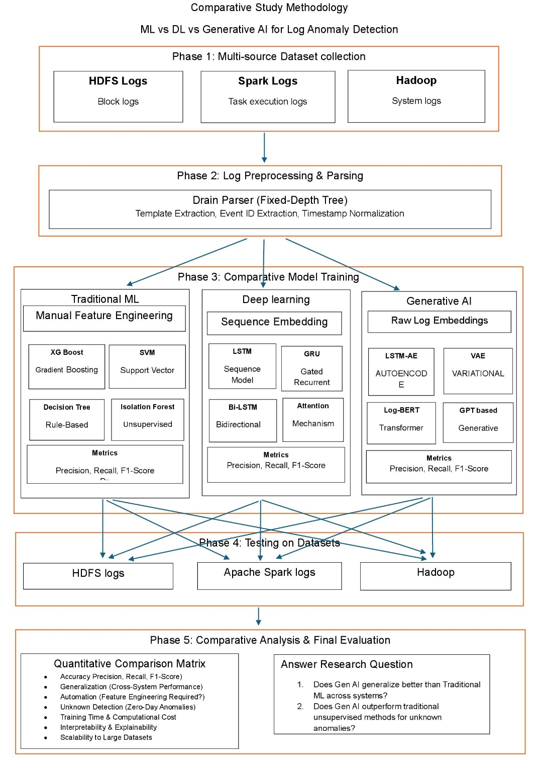
Figure 1 Methodology

Mathematical Formulation of the Detection Problem
The core challenge in automated log anomaly detection is identifying sequence deviations within massive, unstructured event streams. Let the raw log sequence be defined as a continuous stream of events $S=\left\{e_{1},e_{2},…,e_{T}\right\}$, where each $e_{t}$ represents a parsed log event template at timestamp $t$.
The objective of the anomaly detection system is to learn a mapping function $f:S→\left\{0,1\right\}$, where $0$ denotes normal execution and $1$ denotes a system anomaly.

Phase 1: Multi-Source Dataset Collection
A multi-source repository is utilized to ensure rigorous comparative testing across heterogeneous environments:
- HDFS Logs: Collection of block logs.
- Apache Spark Logs: Collection of task execution logs.
- Hadoop: Collection of system logs.

Phase 2: Log Preprocessing & Parsing (Enhanced)
Raw unstructured logs cannot be directly ingested by spatial or sequential models. Raw logs are processed using the Drain Parser, a Fixed-Depth Tree approach. The preprocessing pipeline involves:
- Template Extraction: Utilizing heuristics to separate static text from dynamic variables (e.g., IPs, block IDs).
- Event ID Extraction: Assigning a unique identifier to each structural template.
- Timestamp Normalization: Standardizing chronological deltas to capture execution latency.

Phase 3: Comparative Model Architectures (Enhanced)
The study implements three parallel analytical pipelines:

Traditional Machine Learning (Manual Feature Engineering)

These models depend heavily on the aggregation of Event Count Matrices.
- XGBoost & Random Forest: Utilize gradient boosting and decision tree ensembles to build non-linear decision boundaries across structured event distributions.
- Isolation Forest: Operates under the assumption that anomalies are "few and different," isolating instances by randomly selecting features and splitting values. The anomaly score $s\left(x,n\right)$ for an instance $x$ is defined as:
$$s\left(x,n\right)=2^{-\frac{E\left(h\left(x\right)\right)}{c\left(n\right)}}$$
where $h\left(x\right)$ is the path length and $c\left(n\right)$ is the average path length of unsuccessful searches in a Binary Search Tree.

Deep Learning (Sequence Embedding)
This pipeline evaluates sequence models capable of learning from log data without the rigid manual feature engineering required by traditional ML. Models incorporate Attention Mechanisms, Bidirectional Bi-LSTM, Gated Recurrent GRU, and Sequence Model LSTM.

Generative AI (Raw Log Embeddings)
Generative AI models leverage raw, self-supervised log embeddings. These models are trained strictly on normal operational data to learn the underlying distribution.
- Variational Autoencoder (VAE): The VAE maps input sequences into a latent probabilistic space. The network optimizes the Evidence Lower Bound (ELBO):
$$L\left(θ,ϕ;x\right)=E_{q_{ϕ}\left(z|x\right)}\left[{\log{p}}_{θ}\left(x|z\right)\right]-D_{KL}\left(q_{ϕ}\left(z|x\right)||p\left(z\right)\right)$$
Where the anomaly score is derived from the reconstruction probability.
- LSTM-AE Autoencoder: Reconstructs sequences over time. High reconstruction errors serve as the primary threshold for anomaly detection.

D. Phase 4: Training and Testing Dynamics
To thoroughly assess model efficacy, each trained model is evaluated using a strict train-test split (e.g., an 80/20 division) sourced directly from the exact same dataset.
- Intra-System Validation: The methodology strictly mandates training and testing on the same dataset (e.g., training on HDFS and testing on HDFS) to accurately baseline the system's normal operational parameters.
- Independent System Verification: This self-contained validation is independently repeated across the HDFS, Apache Spark, and Hadoop/OpenStack log collections. This ensures the models' performance consistency is verified across distinct system environments without cross-contaminating the training distributions.

E. Phase 5: Comparative Analysis & Final Evaluation
Models are assessed using a Quantitative Comparison Matrix focusing on metrics such as Precision, Recall, and F1-Score. The evaluation also measures Performance Consistency (evaluation across individual system datasets), Automation (feature engineering requirements), Unknown Detection (zero-day anomalies), Training Time, Interpretability, and Scalability to large datasets. This matrix will directly answer the core research questions regarding Generative AI's capability to maintain high performance across systems and outperform traditional unsupervised methods.

Results and Discussion
This chapter presents the results from simulations based on the methods developed in chapter 4.

Baseline Performance (HDFS v1)
This section documents the comprehensive benchmarking phase evaluating Traditional Machine Learning, Deep Learning, and Generative AI pipelines. Models were evaluated using a strict 80% training and 20% testing split on the HDFS log dataset. The dataset presents a severe class imbalance challenge, comprising 558,223 normal log vectors and 16,838 anomaly vectors. The 20% holdout test set contains a total of 115,013 instances, with 111,645 normal cases and 3,368 anomalies. To address the severe class distribution disparity during training, algorithms like the XGBoost classifier incorporated automated minority class weighting adjustments.

1)Traditional Machine Learning Results:
In this phase, XGBoost and Support Vector Machine (SVM) were applied to detect anomalies in HDFS log data using manually engineered event count features.
- XGBoost: Achieved near-perfect performance, with an anomaly precision of 0.9985, recall of 0.9997, and F1-score of 0.9991. The model made only 5 false positive errors and missed just 1 anomaly out of 3,368 in the test set.
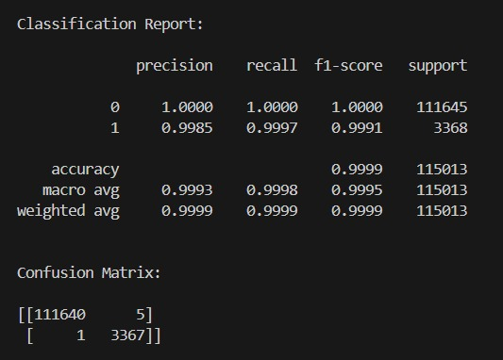
Figure 2 HDFS ML XGBoost Confusion Matrix
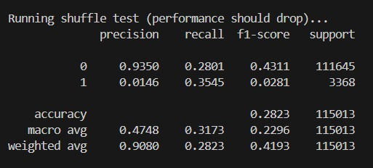
Figure 3 Shuffling Test Performance
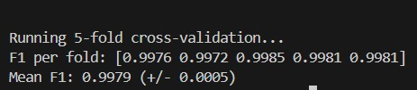
Figure 4 F1 Score

- SVM: Demonstrated strong baseline performance, achieving an anomaly precision of 0.9634, recall of 0.9994, and F1-score of 0.9811. However, it produced 128 false positives and missed 2 anomalies.
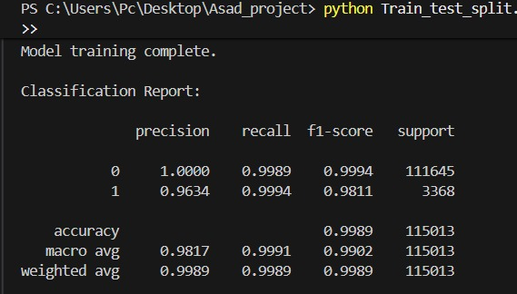
Figure 5 SVM results

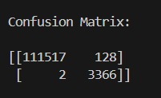
Figure 6 SVM Confusion Matrix

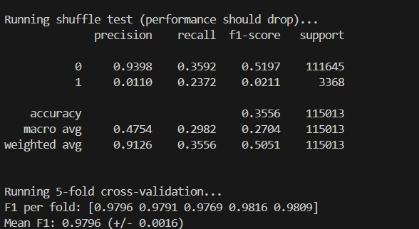
Figure 7 SVM Results after Shuffing

XGBoost distinctly outperformed SVM across all key parameters, highlighting its superior capacity to construct non-linear decision boundaries across complex event distributions.
2) Deep Learning (Supervised) Results:
The supervised Deep Learning pipeline evaluated sequence models capable of learning from log data without the rigid manual feature engineering required by traditional ML.
- LSTM: The Long Short-Term Memory network achieved an anomaly precision of 0.9808, a recall of 0.9988, and an F1-score of 0.9897. The model produced 66 false positives and missed 4 anomalies, while maintaining a perfect ROC-AUC of 1.0.
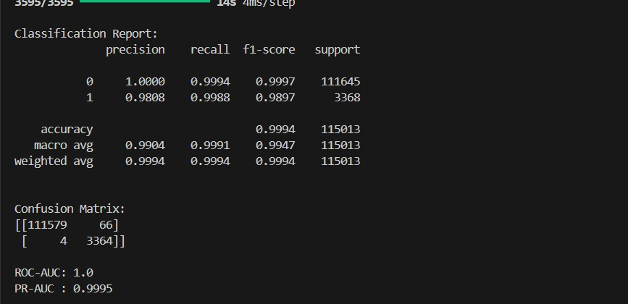
Figure 8 DL LSTM Confusion Matrix and ROC-AUC results
- GRU: The Gated Recurrent Unit performed comparably to the LSTM, achieving a precision of 0.9808, a recall of 0.9991, and an F1-score of 0.9899. It also produced 66 false positives but missed only 3 anomalies, similarly achieving an ROC-AUC of 1.0.
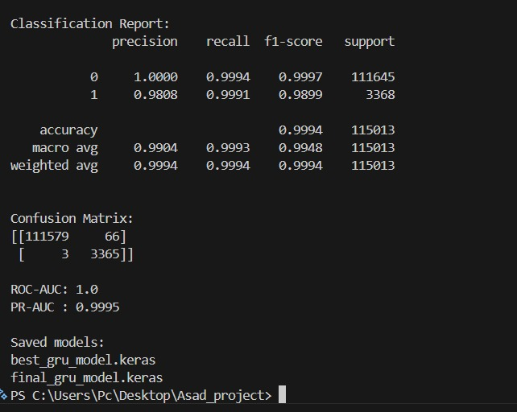
Figure 9 GRU Confusion Matrix and ROC-AUC results
3) Generative AI Results:
The Generative AI models were trained exclusively on normal data sequences (normal-only), evaluating their capability to reconstruct logs and detect anomalies through reconstruction errors without relying on supervised anomaly labels.
- LSTM Autoencoder: Achieved an anomaly precision of 0.7232, a recall of 0.8818, and an F1-score of 0.7946. The model resulted in 1,137 false positives and 398 missed anomalies, with an ROC-AUC of 0.9964 and PR-AUC of 0.9049.
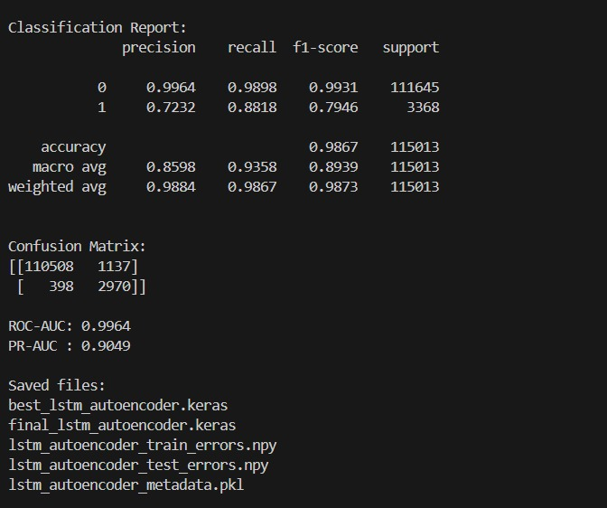
Figure 10 GEN AI LSTM Autoencoder Confusion Matrix and ROC-AUC results
- LSTM-VAE: The Variational Autoencoder yielded an anomaly precision of 0.6944, a recall of 0.7429, and an F1-score of 0.7178. It generated 1,101 false positives and 866 missed anomalies, achieving an ROC-AUC of 0.9876 and PR-AUC of 0.7854.
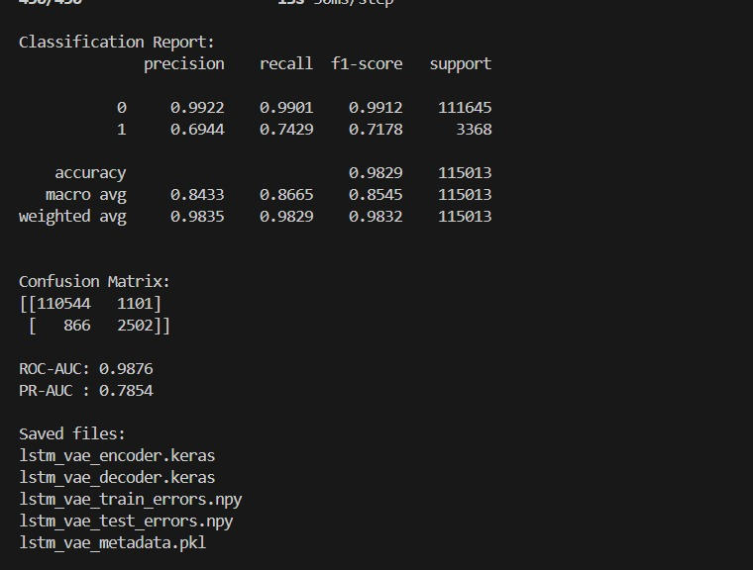
Figure 11 GEN AI LSTM VAE Confusion Matrix and ROC-AUC results
4) Comparative Analysis Synthesis (HDFS):
The benchmarking results present a clear trade-off between absolute accuracy and functional autonomy.
- Supervised Dominance: Traditional supervised models like XGBoost achieve near-perfect F1-scores (0.9991). However, their reliance on manual Event Count Matrices limits operational scalability.
- Deep Learning Autonomy: Supervised Deep Learning sequence models (LSTM and GRU) successfully matched this high accuracy (F1-scores of ~0.99) while eliminating the need for rigid manual feature extraction, proving their efficacy at understanding sequential log patterns.
- Generative Potential: The Generative AI models (LSTM Autoencoder and VAE) exhibit lower raw precision and recall metrics but operate under a fundamentally different, strictly unsupervised paradigm. Because they are trained exclusively on normal system behavior, their F1-scores (~0.71 - 0.79) represent a baseline capability for discovering unknown, zero-day anomalies.
Table 1 HDFS All Models Comparison
Model | Type | Anomaly Precision | Anomaly Recall | Anomaly F1 | ROC-AUC | PR-AUC
XGBoost | Traditional ML | 99.85% | 99.97% | 99.91% | - | -
SVM | Traditional ML | 96.34% | 99.94% | 98.11% | - | -
LSTM | Supervised DL | 98.08% | 99.88% | 98.97% | 100.00% | 99.95%
GRU | Supervised DL | 98.08% | 99.91% | 98.99% | 100.00% | 99.95%
LSTM Autoencoder | Generative/ Normal-only | 72.32% | 88.18% | 79.46% | 99.64% | 90.49%
LSTM-VAE | Generative / Normal-only | 69.44% | 74.29% | 71.78% | 98.76% | 78.54%

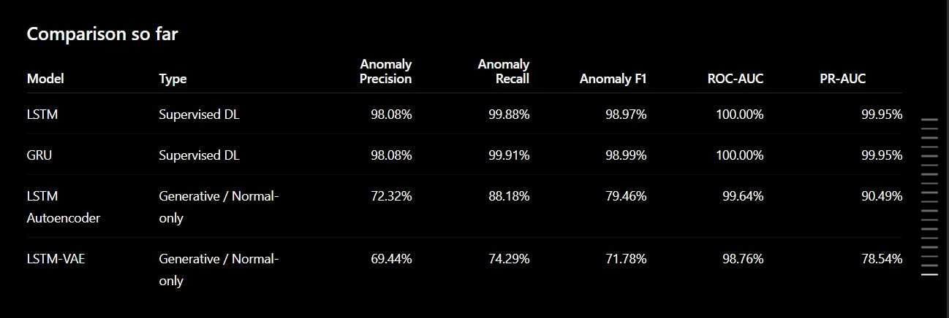
Figure 12 HDFS Comparison Matrix

Spark Logs Analysis
1) Machine Learning Results:
The traditional ML training logs show that Random Forest achieved a near-perfect ROC-AUC of 0.9902, vastly outperforming unsupervised methods like Isolation Forest (0.9559) and One-Class SVM (0.2388). However, despite the high ROC-AUC, the Isolation Forest model struggled with precision (0.04) and F1-score (0.04) for anomaly detection.
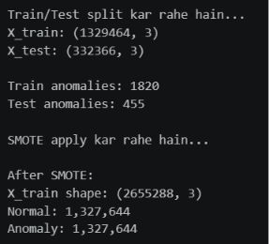
Figure 13 Spark ML Train and Test Results
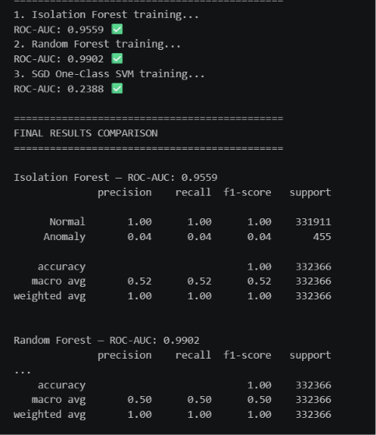
Figure 14 Isolation Forest and Random Forest Results

2) Deep Learning Results:
The LSTM Autoencoder model achieved a strong ROC-AUC score of 0.9822 and an excellent recall of 0.93 for anomalies. However, its precision was extremely low at 0.02, leading to an F1-score of just 0.05, indicating a high rate of false positives.
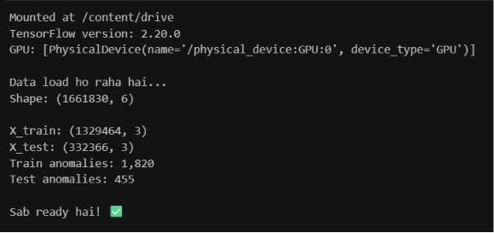
Figure 15 DL Train and Test Results
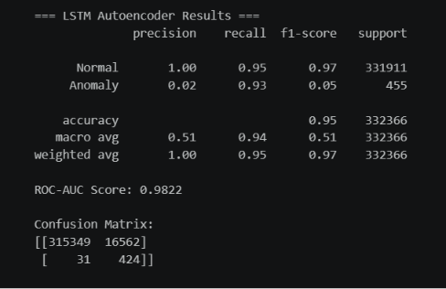
Figure 16 LSTM Results

The CNN Classifier recorded the highest overall ROC-AUC for the Spark dataset at 0.9978, with a perfect recall of 1.00. Similar to the LSTM model, it suffered from severe precision issues (0.09), resulting in a low F1-score of 0.16.
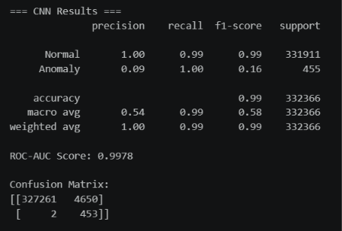
Figure 17 CNN Results
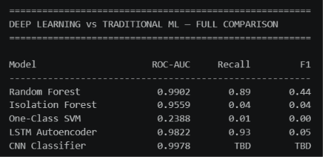
Figure 18 DL vs ML Comparison Results
3) Generative AI Results:
Both generative models performed poorly on the Spark dataset. The Variational Autoencoder (VAE) achieved an ROC-AUC of 0.7700 but managed an F1-score of only 0.01, while the Generative Adversarial Network (GAN) failed to detect anomalies effectively, recording an ROC-AUC of 0.2479 and an F1-score of 0.01.
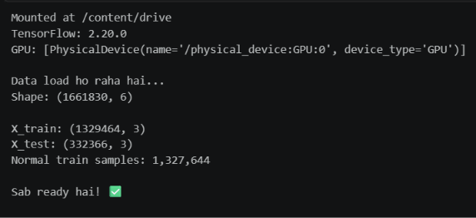
Figure 19 Gen AI Train and Test Results
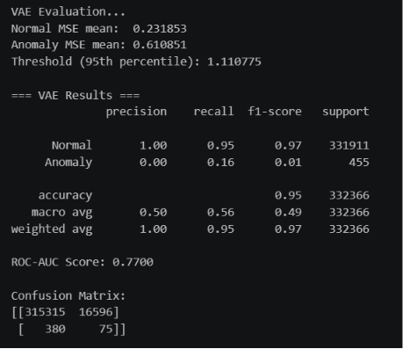
Figure 20 VAE Results
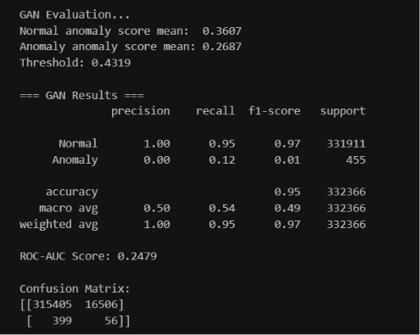
Figure 21 GAN Results
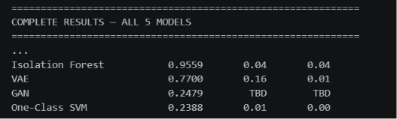

Spark Comparative Analysis Synthesis:
The Spark execution logs presented a severe degradation in model efficacy across all architectures.
- Precision Collapse: The complex, overlapping nature of Spark execution logs created a massive false-positive problem. For instance, the LSTM Autoencoder generated 16,562 false positives, dropping its F1-score to just 0.05 despite a strong ROC-AUC of 0.9822.
- Generative Failure: Both generative models performed exceptionally poorly on the Spark dataset. The structural noise and high concurrency of Spark tasks fundamentally disrupted the VAE and GAN's ability to map a stable latent distribution, resulting in F1-scores of 0.01.

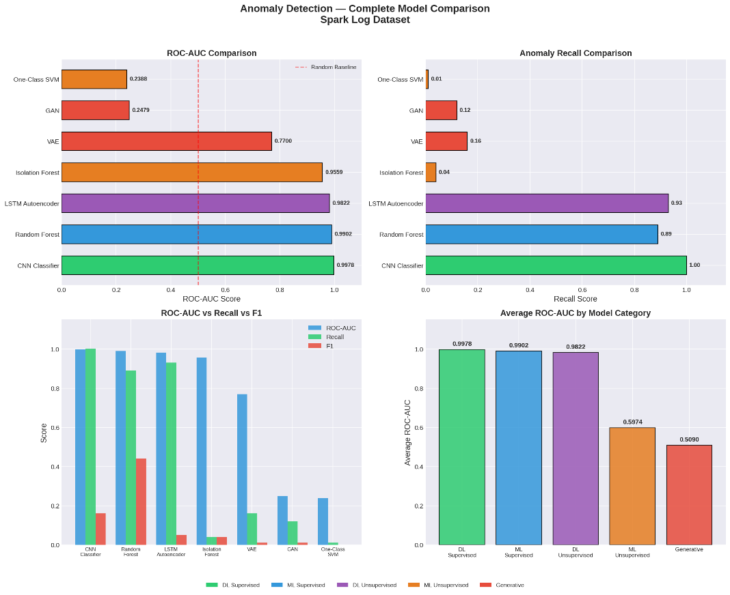
Figure 22 Spark logs Model Comparison
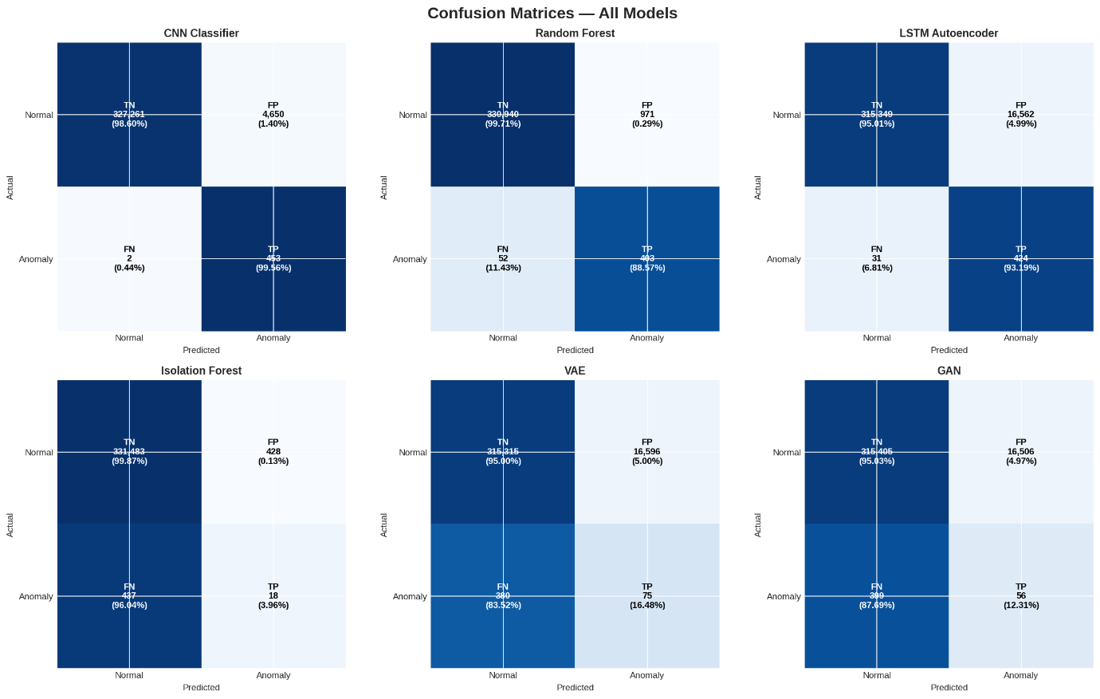
Figure 23 Spark logs Confusion Matrix
Table 2 Spark Logs All Model Results Summary
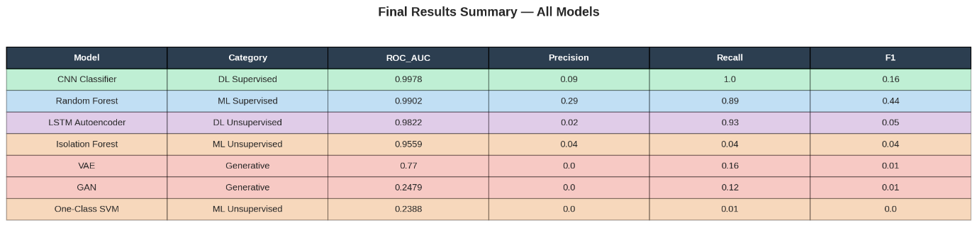

C. Hadoop Logs Analysis
1) Traditional Machine Learning Logs:
In the Hadoop environment, the Random Forest model achieved perfect metrics across the board, logging an ROC-AUC, Recall, and F1-score of 1.0000. Conversely, Isolation Forest and One-Class SVM performed poorly, with ROC-AUC scores of 0.2092 and 0.2383, respectively.
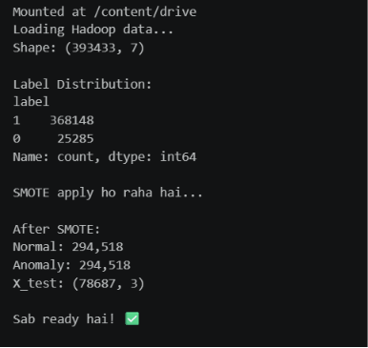
Figure 25 Hadoop ML Label Logs distribution

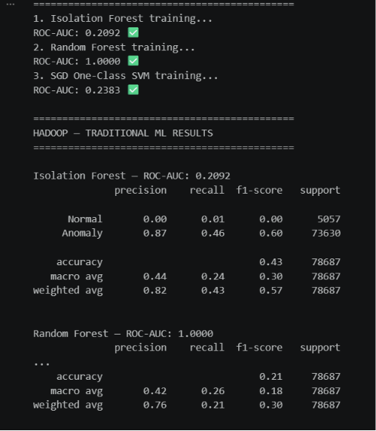
Figure 26 ML Isolation Forest and Random Forest Results
2) Deep Learning (LSTM and CNN):
Deep learning performance was mixed on the Hadoop data. The CNN Classifier performed exceptionally well with an ROC-AUC of 0.9617 and a strong F1-score of 0.91. The LSTM Autoencoder, however, saw a significant drop in performance compared to its Spark results, achieving an ROC-AUC of 0.6519 and an F1-score of 0.45.
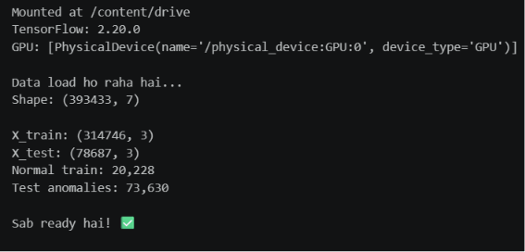
Figure 27 DL train test results
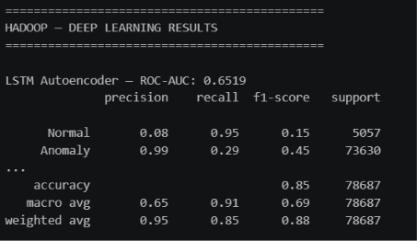
Figure 28 LSTM Autoencoder Results
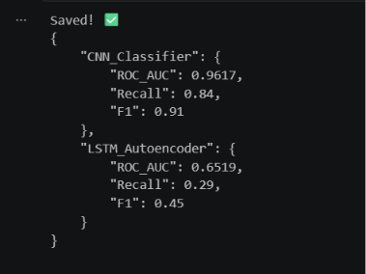
Figure 29 CNN and LSTM comparison

3) Generative AI (VAE and GAN):
Generative models continued to underperform on the Hadoop dataset. The GAN achieved an ROC-AUC of 0.6133 with an F1-score of 0.03, while the VAE recorded an ROC-AUC of 0.5235 and an F1-score of 0.12.
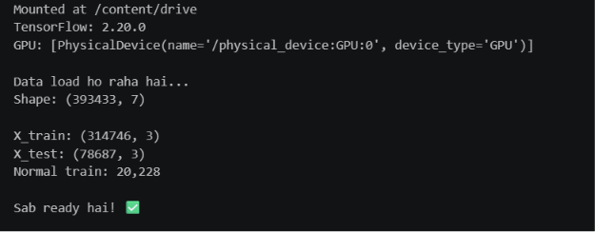
Figure 30 Gen AI train test results

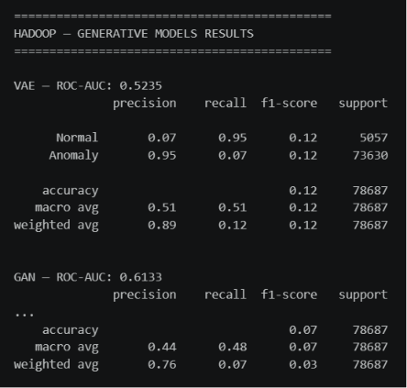
Figure 31 VAE and GAN results

4) Hadoop Comparative Analysis Synthesis:
The summary table and confusion matrices for Hadoop confirm the absolute superiority of the Random Forest model, which recorded 0 false positives and 0 false negatives. The CNN also demonstrated high accuracy with only 50 false positives out of tens of thousands of records.
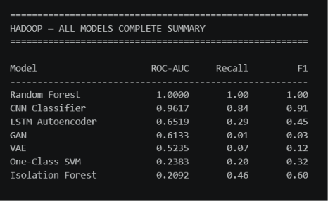
Figure 32 Hadoop All Model Results Summary
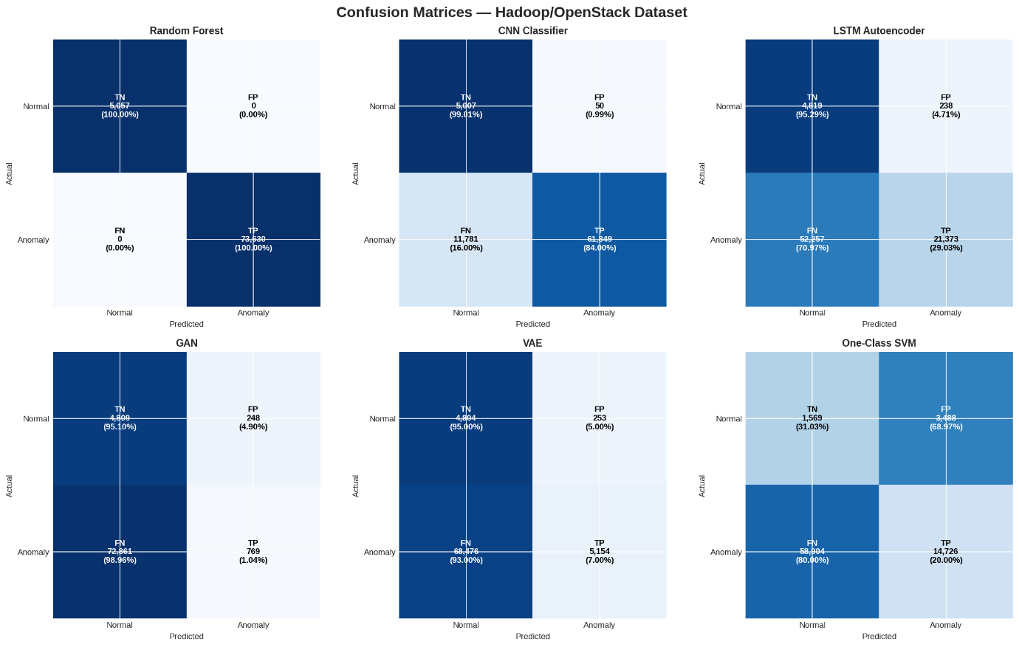
Figure 33 Hadoop All Model Confusion Matrix

D. Overall Performance Synthesis (Spark vs. Hadoop)
The final heatmap provides a clear visual summary: Random Forest is the most consistently reliable model across both datasets, maintaining high ROC-AUC and the best relative F1-scores. CNN classifiers show excellent ROC-AUC but are highly susceptible to F1-score degradation depending on the dataset (0.16 on Spark vs. 0.91 on Hadoop), while Generative and Traditional Unsupervised models exhibit consistently weak performance across both environments.

Table 3 Spark vs Hadoop All Models Results
Model | Category | HDFS F1 | Spark F1 | Hadoop F1
XGBoost | Traditional ML (Supervised) | 0.9991 | - | -
SVM | Traditional ML (Supervised) | 0.9811 | - | -
Random Forest | Traditional ML (Supervised) | - | 0.44 | 1
LSTM | Deep Learning (Supervised) | 0.9897 | - | -
GRU | Deep Learning (Supervised) | 0.9899 | - | -
CNN Classifier | Deep Learning (Supervised) | - | 0.16 | 0.91
Isolation Forest | Traditional ML (Unsupervised) | - | 0.04 | 0.6
One-Class SVM | Traditional ML (Unsupervised) | - | 0 | 0.32
LSTM Autoencoder | Generative / Unsupervised DL | 0.7946 | 0.05 | 0.45
VAE / LSTM-VAE | Generative | 0.7178 | 0.01 | 0.12
GAN | Generative | - | 0.01 | 0.03
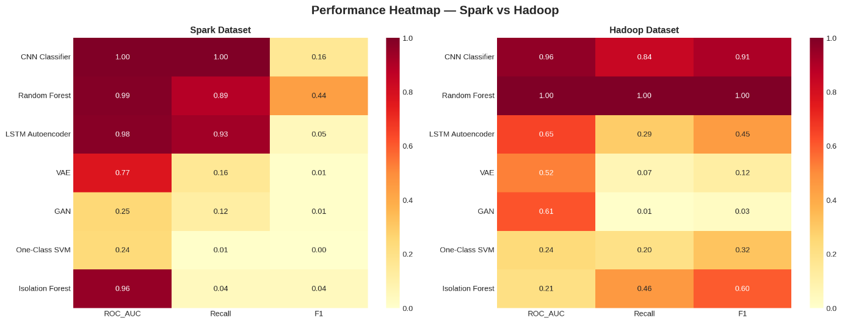
Figure 34 Performance Matrix Spark vs Hadoop
Key Takeaways from the Data:
- The HDFS Illusion: Almost everything performed exceptionally well on HDFS, making it seem like the problem of anomaly detection was solved.
- The Spark Reality Check: Spark completely broke the models. The complex, overlapping nature of Spark execution logs created a massive false-positive problem, dragging almost every model's F1-score below 0.50.
- The Generative Struggle: While Generative AI (LSTM Autoencoder, VAE, GAN) is theoretically great because it doesn't need manual feature engineering, it consistently struggled with noise across all environments, peaking at just 0.7946 on the "easy" HDFS dataset and failing entirely on Spark and Hadoop.

Conclusions and Recommendations

Conclusions
This thesis presented a comprehensive comparative study evaluating Traditional Machine Learning (ML), Deep Learning (DL), and Generative AI models for automated log anomaly detection across three heterogeneous environments: HDFS, Apache Spark, and Hadoop.
The empirical findings reveal a distinct trade-off between absolute accuracy and functional autonomy. Traditional supervised classifiers (like XGBoost and Random Forest) achieve near-perfect F1-scores on highly balanced or structurally consistent datasets like HDFS and Hadoop, but they remain fundamentally brittle and heavily dependent on labor-intensive, manual feature engineering. Supervised Deep Learning architectures (such as CNNs, LSTMs, and GRUs) successfully eliminate the need for rigid manual feature extraction while maintaining strong performance, yet they demonstrate severe volatility and performance degradation when confronted with the high noise levels and complex concurrency patterns inherent to Spark execution logs.
Conversely, Generative AI models (such as the LSTM Autoencoder, VAE, and GAN) operating under a strictly unsupervised, normal-only paradigm exhibit lower raw precision and F1-scores across the board. However, their consistently high ROC-AUC scores demonstrate that the underlying reconstruction error distributions remain highly separable. Ultimately, while supervised models dominate under closed-world assumptions, generative architectures establish a vital baseline capability for discovering unknown, zero-day anomalies without requiring prior exposure to production failure states.

Recommendations for Further Work
To address the limitations identified in this comparative framework, future research will focus on the following directions:
- Dynamic Thresholding Mechanisms: Implementing adaptive or extreme value theory (EVT) thresholding to replace static percentile cutoffs, thereby minimizing the high false-positive rates observed in generative models on complex datasets like Spark.
- Concept Drift Mitigation: Investigating online incremental learning and fine-tuning paradigms to ensure deep generative models remain robust as log formats evolve over time alongside software updates.
- Fine-Grained Parameter Classification: Extending the semantic capabilities of raw log embeddings to parse and categorize specific variable fields (such as status codes, IP addresses, and block IDs) rather than relying solely on event sequence IDs.
- Hybrid Neuro-Symbolic Frameworks: Designing unified frameworks that combine the statistical robustness of traditional ensemble methods with the unsupervised flexibility of generative sequence modeling.

References
[1] Zhu, J., He, S., He, P., Liu, J., & Lyu, M. R. (2023). "Loghub: A Large Collection of System Log Datasets for AI-driven Log Analytics." In Proceedings of the 2023 IEEE 34th International Symposium on Software Reliability Engineering (ISSRE), pp. 355-366.
[2] Khan, M. A. M. (2026). "Generative Models vs Traditional AI-Driven Anomaly Detection in Large-Scale System Logs – A Comparative Study." Master's Thesis, Air University, Department of Computer Science (MSAI Program). Referenced from the source working file: "final thesis report asad msai 4 23-6-2026.docx".
[3] He, P., Zhu, J., Zheng, Z., & Lyu, M. R. (2017). "Drain: An online log parsing approach with fixed depth tree." In Proceedings of the 2017 IEEE International Conference on Web Services (ICWS), pp. 33-40.
[4] Du, M., Li, F., Zheng, G., & Srikumar, V. (2017). "DeepLog: Anomaly detection and diagnosis from system logs through deep learning." In Proceedings of the 2017 ACM SIGSAC Conference on Computer and Communications Security, pp. 1285-1298.
[5] Zhang, X., Xu, Y., Qin, S., He, S., Biao, Q., Li, Z., ... & Zhang, D. (2021). "Onion: Identifying incident-indicating logs for cloud systems." In Proceedings of the 29th ACM Joint Meeting on European Software Engineering Conference and Symposium on the Foundations of Software Engineering (ESEC/FSE), pp. 1253-1263.
[6] Xu, W., Huang, L., Fox, A., Patterson, D. A., & Jordan, M. I. (2009). "Detecting large-scale system problems by mining console logs." In Proceedings of the ACM SIGOPS 22nd Symposium on Operating Systems Principles (SOSP), pp. 117-132.
[7] Liu, F. T., Ting, K. M., & Zhou, Z. H. (2008). "Isolation forest." In Proceedings of the 8th IEEE International Conference on Data Mining (ICDM), pp. 413-422.
[8] Lin, Q., Zhang, H., Lou, J. G., Zhang, Y., & Chen, X. (2016). "Log clustering based problem identification for online service systems." In Proceedings of the 38th International Conference on Software Engineering Companion (ICSE-C), pp. 102-111.

Appendix-A
Describe your Table here.
Table A- 1: Table caption here single line Times New Roman 12pt

Turnitin Originality Report
(stamped and signed by QEC and to be submitted separately)

